English – System Development
Develop autonomy, confidence, and the ability to present technical content in English related to IT system development.

1 – Introduction to IT Administration & Project Launch
- What do IT administrators do in companies?

IT administrators work with both hardware and software. Their responsibilities include: maintaining the company's networks, servers, computers, and software; optimizing infrastructure to increase productivity; and helping the company with cybersecurity methods. Two common functions of an IT administrator are: working with databases, ensuring the security and integrity of company data. Another function is: working with networks, managing the local network and the company's network system, ensuring system security against cyberattacks.

- Search and define terms such as spreadsheet, database, system administrator, server, peripheral.

Spreadsheet - A spreadsheet is a computer application for organizing and storing data arranged in rows and columns. The application can use this data to perform complex calculations and create charts. Common applications: Excel, Google Sheets, and Apple Numbers.

Database - A database is a collection of data organized and saved on a computer. This data can be easily modified with specialized software, and you can store virtually anything, including images and videos, with easy access from the computer.

System Administrator - A system administrator is a professional responsible for a company's IT infrastructure, ensuring the security, stability, and performance of IT. They may upgrade the hardware of the company's PCs, resolve network problems such as slowness, or use a Python script to automate routine company tasks.

Server - A server is a computer that can store and provide data, services, programs, and other resources to other computers or devices, called "clients." Servers use the internet to send data to clients. An example of this is when you chat with ChatGPT. ChatGPT is AI software that runs on a computer within a database, far from your home. Your messages are sent to it over the internet, and the replies are sent to you over the internet.

Peripheral - A peripheral is a device that connects to a computer or mobile phone and adds functionality to the device. An example of this is a keyboard that converts the code of the pressed key into binary code and sends it to the computer via electrical signals, and the computer converts this binary code into a character.

- Create a collaborative glossary using Google Docs or another shared tool.
Glossary

- Case-sensitive: Generally, applies to a data input field; a case-sensitive restriction means lower-case letters are not equivalent to the same letters in upper-case. Example: "data" is not recognized as being the same word as "Data" or "DATA".
- GUI: Graphical user interface; a mouse-based system that contains icons, drop-down menus, and windows where you point and click to indicate what you want to do. All new Windows and Macintosh computers currently being sold utilize this technology.
- IDE (Integrated Development Environment): An application that facilitates software developers with writing code.
- Web Hosting - is a service that makes websites accessible on the internet by storing website files (HTML, CSS, images, videos) on specialized computers called servers
- Fork: A fork is a copy of an existing software project at some point to add someone's own modifications to the project.

- Explains 5 vocabulary terms with examples.

- Encryption
Encryption is a way to protect information by transforming it into a secret code so only authorized people can read it.
Example: When you enter your password on a website, encryption keeps it safe from hackers.

- Flash drive
A flash drive is a small portable device used to store and transfer files between computers.
Example: You can save a school project on a flash drive and open it on another computer.

- Header
The header is the top section of a website that usually contains the logo and navigation menu.
Example: On most websites, the header includes buttons like “Home”, “About”, and “Contact”.

- Padding
Padding is the space inside an element, between the content and its border.
Example: Adding padding to a button makes the text inside it not touch the edges.

- WebSocket
WebSocket is a technology that allows real-time communication between a client and a server.
Example: Chat apps use WebSocket so messages appear instantly without refreshing the page.

- Research 3 real companies that use spreadsheets for administration.

Amazon - Business Analyst II - 5+ years of Excel experience

Meta - Construction Manager - Data Center Design, Engineering and Construction - Proficient working knowledge of MS Word, Excel, and PowerPoint

Walmart - (USA) Senior, Data Analyst - Proficient in SQL, RedShift, Oracle, Tableau, Excel, and PowerPoint.

2 – Spreadsheets and Basic Formulas
- Research: What is a spreadsheet and why do IT teams use it?

Spreadsheet - A spreadsheet is a computer application for organizing and storing data arranged in rows and columns. The application can use this data to perform complex calculations and create charts. Common applications: Excel, Google Sheets, and Apple Numbers.
Excel is essential in most businesses because it's a very easy way to read data. People without technical knowledge can understand Excel. Therefore, it's important for a developer to learn how to create a data file for Excel using code, as this makes it easier for both individuals and businesses to read, understand, and manipulate data.

- Vocabulary: cell, row, column, formula, function, SUM, AVERAGE.

- Cell – Célula
A cell is a single box in a spreadsheet where you can enter data.
Example: Cell A1 can contain a number like 10 or a word like “Name”.

- Row – linha, linhas
A row is a horizontal line of cells in a spreadsheet.
Example: Row 1 usually contains titles like Name, Age, and Grade.

- Column - coluna
A column is a vertical line of cells in a spreadsheet.
Example: Column A can contain all the names of students.

- Formula – Fórmula
A formula is an expression used to calculate values in a spreadsheet.
Example: =A1 + A2 adds the values of two cells.

- Function - Função
A function is a predefined formula that performs a specific calculation.
Example: SUM is a function used to add numbers automatically.

- SUM – addition – calculate the total
SUM is a function that adds a group of numbers.
Example: =SUM(A1:A5) adds all values from cell A1 to A5.

- AVERAGE - Média
AVERAGE is a function that calculates the mean of a group of numbers.
Example: =AVERAGE(A1:A5) calculates the average value of cells A1 to A5.

- Create a spreadsheet with basic formulas.
Example: 'The formula calculates the total by adding the numbers'.
Add | 1 | 1 | "=b1+c1"
Subtract | 4 | 2 | "=b2-c2"
Multiply | 10 | 5 | "=B3*C3"
Divide | 10 | 5 | "=B4/C4"
Sum | 20 | 10 | 10 | "=SUM(B5; C5;D5)"
Min | 10 | 2 | 40 | "=MIN(B6;C6;D6)"
Max | 100 | 200 | "=MAX(B7;C7)"
Average | 100 | 100 | "=AVERAGE(B8;C8;)"

- Presentation: Demonstrate their spreadsheet and explain formulas.

- Introduction to Databases
- What is a database?
A database is an organized collection of information stored electronically, mostly on a computer, so it can be saved, updated, searched, and protected. Instead of keeping data scattered across many files or physical paper, a database stores it in a structured way digitally, which helps applications retrieve the right information quickly and consistently.

- Vocabulary: table, record, field, query, data storage.

Table - tabela: a structured set of data in a database, usually like a spreadsheet with rows and columns.
Example: A “Users” table.
Record (complete horizontal row): horizontal row of data. one item inside a table, representing a single entity.
Example: One user account in the “Users” table.
Field (vertical - column): a specific attribute stored for each record.
Example: email, password_hash, created_at. is a specific category of information (an attribute) represented as a vertical column in a dataset
Query (consulta): a request to read or change data in a database.
Example: “Show all unread emails for this user.”
Data storage: the way data is saved so it persists over time (on disks/SSDs, cloud storage, etc.). magnetic, optical or mechanical media that records and preserves digital information
Example: The database files are stored on a server’s SSD and backed up daily.

- Research: Databases used by email systems, websites, and apps.

Email systems use databases to store message metadata (sender, recipient, subject, date, read/unread), folders/labels, contacts, and sometimes indexes for search; the actual message content and attachments may be stored in dedicated storage but referenced from the database. relational databases like MySQL, PostgreSQL, or MariaDB

Websites use databases to store user accounts, login credentials (as password hashes), profiles, posts/comments, orders, and session or audit data. relational databases (SQL) like MySQL and PostgreSQ

Mobile apps often use a local database (like SQLite) to store settings, cached content, and offline data, then sync that data to a cloud database so the same account works across devices. google firebase cloud

- Presentation: Explain how information is organized in databases.

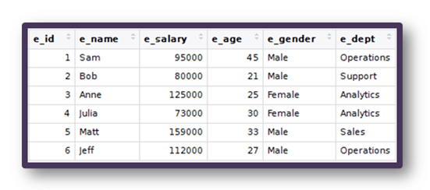
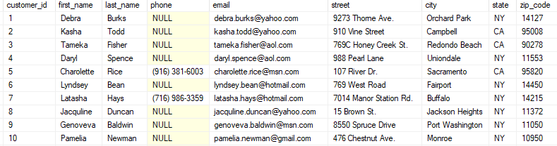
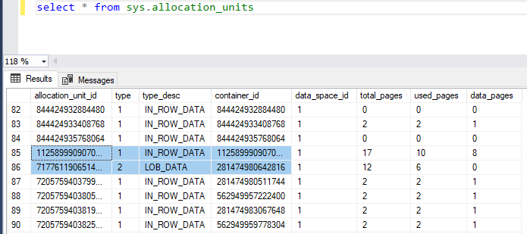

4 – Explaining Processes (by + -ing)
- Grammar focus: Explaining processes (by + verb‑ing).
Example: 'Data is stored by saving records in database tables.'
- Students explain how databases work using this structure.
- Presentation: How websites store user data.

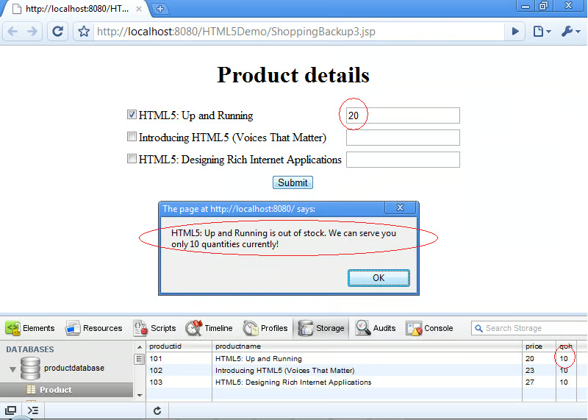

5 – System Administration Roles
- Research: Responsibilities of a system administrator.

A system administrator is responsible for keeping an organization’s IT environment working reliably and securely. Typical responsibilities include managing user accounts and access, monitoring servers and networks, installing updates, configuring backups, responding to incidents, documenting changes, and helping users troubleshoot hardware/software issues.

- Vocabulary: network monitoring, backups, security updates, troubleshooting.

Network monitoring: observing networks/servers with tools and alerts to detect problems (downtime, high latency, packet loss). Example: Getting an alert when the internet link goes down.
Backups: copies of important data that can be restored after deletion, failure, or ransomware. Example: Daily backup of the company database to cloud storage.
Security updates: patches that fix vulnerabilities and improve security. Example: Updating Windows/Linux to close known security holes.
Troubleshooting: diagnosing and fixing issues step by step. Example: Checking logs to find why a service stopped working.

- Create a 'Day in the Life of a System Administrator' presentation.
- Presentation practice.

6 – Hardware and Peripherals
- Research task: Input, output, and storage peripherals.

Peripherals can be grouped by function: input devices send data to the computer (keyboard, mouse, scanner); output devices present data from the computer (monitor, printer, speakers); and storage devices keep data for later (external SSD, USB flash drive). They connect by USB, Bluetooth, Wi-Fi, or other interfaces and communicate through drivers so the operating system can use them.

- Vocabulary: keyboard, mouse, printer, scanner, webcam, external drive.

Keyboard: an input device used to type text and commands. Example: Typing a password.
Mouse: an input device used to point, click, and drag. Example: Selecting a file.
Printer: an output device that produces a paper copy. Example: Printing a report.
Scanner: an input device that converts paper documents into digital files. Example: Scanning a contract to PDF.
Webcam: an input device that captures video. Example: Video meetings.
External drive: a storage device connected to the computer to save files. Example: Backing up photos to an external SSD.

- Create a poster on Canva explaining peripheral functions.
- Presentation: Explain how peripherals interact with computers.

